9. 5. 2016 WORKSHOP
GEOMORPHIC ANALYSIS OF FLUVIAL PROCESSES
IN GRAVEL-BED STREAMS

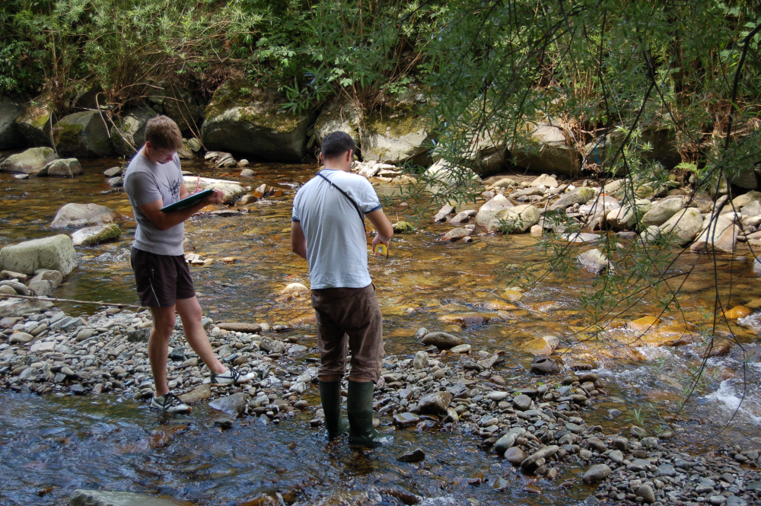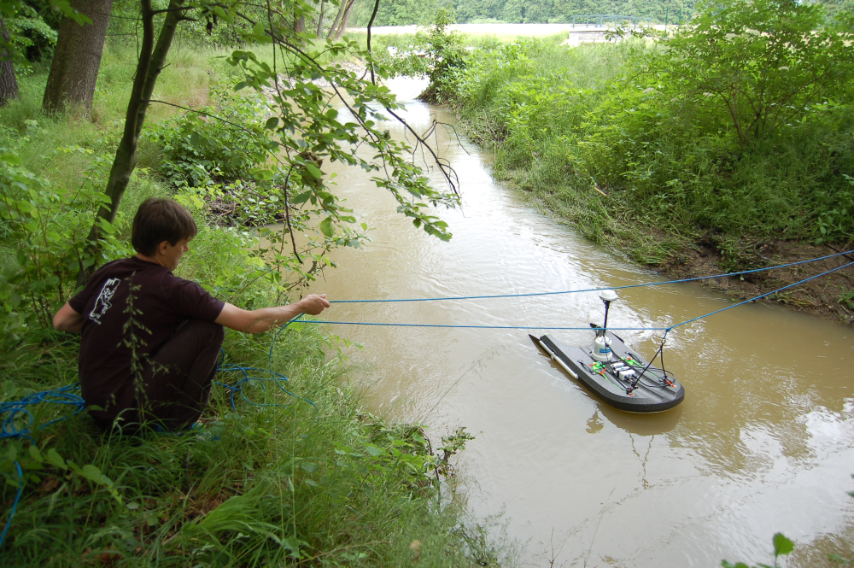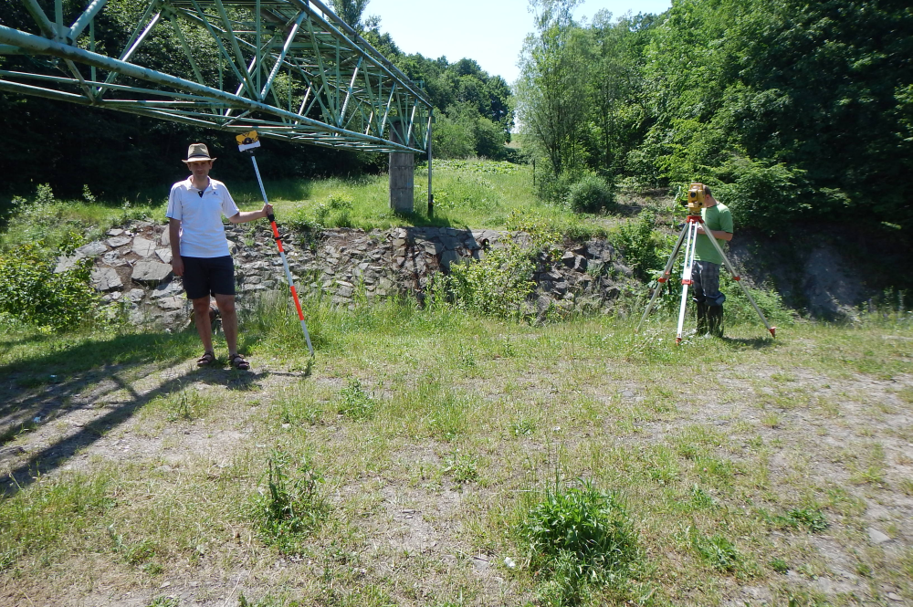

What is it about?
Many aspects of fluvial processes and morphology may be measured to help assess conditions of rivers. Modern research methods in fluvial geomorphology provide an integrated approach to the guidance for researchers to answer questions on river behaviour. The workshop of “Measurement methods of fluvial geomorphology parameters” is addressed to those students and young researchers who are dealing with river systems, hydrology or river restoration. The general aim of the workshop is a demonstration of modern methods and its application in fluvial-geomorphic research. The workshop will be focussed on basic methodologies for hydromorphology assessment, bed-sediment sampling and discharge measurements. Firstly, the workshop will be started by short lectures introducing to the theoretical background of methods used in fluvial geomorphology. Next, we will focus on field data collection in selected river basin with subsequent analysis of obtained data, e.g., by using of BAGS (Bedload Assessment for Gravel-Bed Streams) software or Sedimetrics Digital Gravelometer. Suitable for Ph.D. and MSc students, but not exclusively.

Schedule 9. 5. 2016:
9:00 – 10:30 ……… Theoretical background of methods used in fluvial geomorphology:
- basic methodologies for hydromorphology and channel evolution trajectory,assessment,
- bed sediment sampling procedures and equipment,
- discharge measurements.
10:30 – 11:30 …….. Transport from the Department of Physical Geography and Geoecology (Chittussiho 10, Ostrava, Czech Republic) to the Velký potok study site.
11:30 – 15:00……… Field visit and exercises, field data collection:
- hydromorphology assessment of fluvial system,
- bed sediment sampling procedures and methods,
- discharge measurements,
- measurements of cross-sectional geometry.
15:00 – 16:00 …….. Transport from the the Velký potok study site
to the Department of Physical Geography and Geoecology (Chittussiho 10, Ostrava, Czech Republic)
16:00 – 18:00 …….. Analysis of collected data:
- automatized bed sediment analysis by using of Sedimetrics Digital Gravelometer,
- analysis of potential sediment transport by using of BAGS (Bedload Assessment for Gravel-Bed Stream) software.

Lecturers: RNDr. Václav Škarpich, Ph.D., RNDr. Tomáš Galia, Ph.D.
10. 5. 2016 WORKSHOP II
GEOMORPHIC ANALYSIS OF GRAVITATIONAL PROCESSES
IN SEDIMENTARY ROCKS

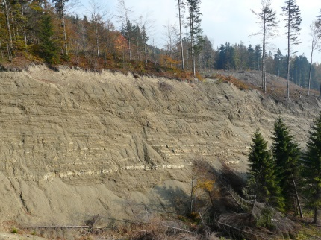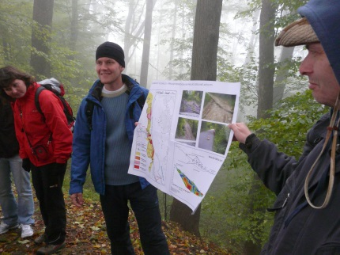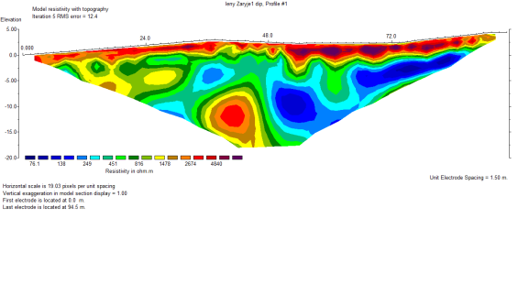

What is it about?
Deep-seated slope deformations are one of the main geomorphic processes affecting sedimentary rocks (e.g. flysch rocks of the Moravskoslezské Beskydy Mts., Outer Western Carpathians). The workshop will be focused on theoretical background of these processes in the field, recognition of particular terrain features connected with slope development, practical measurements (electrical resistivity tomography) and data analyses and modelling using RES2DINV and DIPS softwares. Suitable for Ph.D. and MSc students, but not exclusively.

Schedule 10. 5. 2016:
8:00 – 12:00 ……… Terrain recognition focused on deep-seated slope deformation (Moravskoslezské Beskydy Mts.):
- theoretical background,
- recognition of particular terrain features,
- structural measurements and geophysics (electrical resistivity tomography).

12:00 – 14:00 …….. Lunch and transport to the department (Chittussiho 10, Ostrava, Czech Republic).

14:00 – 16:00 ……… Data management and analyses:
- results of electrical resistivity tomography measurements using RES2DINV software,
- results of structural measurements,
- slope deformation mechanics modelling (DIPS software)
- analyses of LIDAR data (digital model of relief).

Lecturers: RNDr. Jan Lenart, Ph.D., Mgr. Michal Břežný

As a gift from both workshops, each participant will receive a certificate of completion.

Questions and registrations should be sent to jan.lenart@osu.cz.
REGISTRATION
Name:
Surname:
Organization:
Contact (phone, e-mail):
Invoicing details (including address, account, VAT, IBAN, etc…):

Fluvial workshop: YES (500 CZK or 19 E) / NO
Gravitational workshop: YES (500 CZK or 19 E) / NO
Total price*: __CZK or __ E

*Registration includes:
- lectures with guidance
- transport in the field
- use of measuring equipment
- use of softwares
- refreshment
- certificate of completion

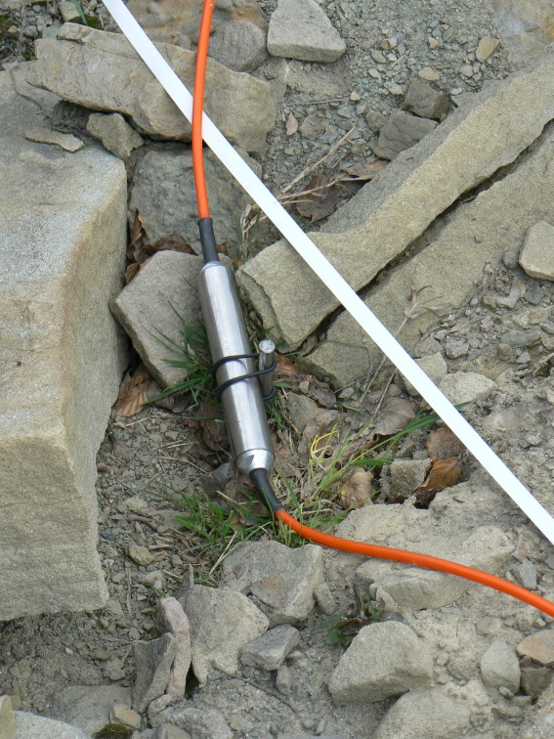
Important dates:
30. 4. end of registration

